# SQL COMMANDS

1. Database: hospital_management



1. CREATE COMMANDS FOR EACH TABLE:

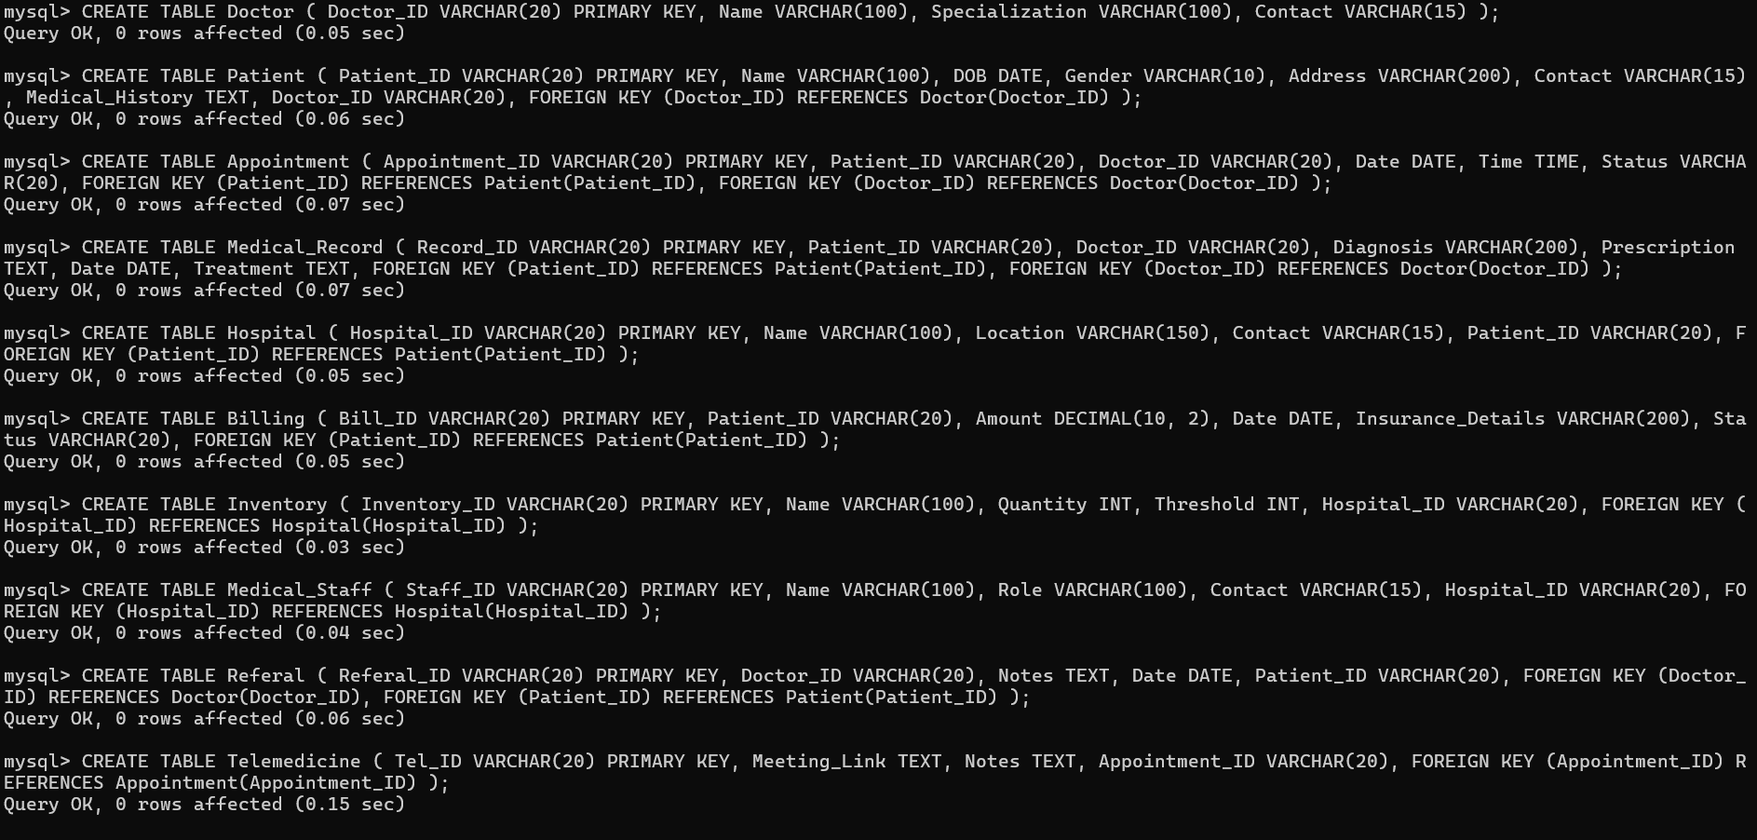

1. INSERT COMMANDS FOR EACH TABLE:

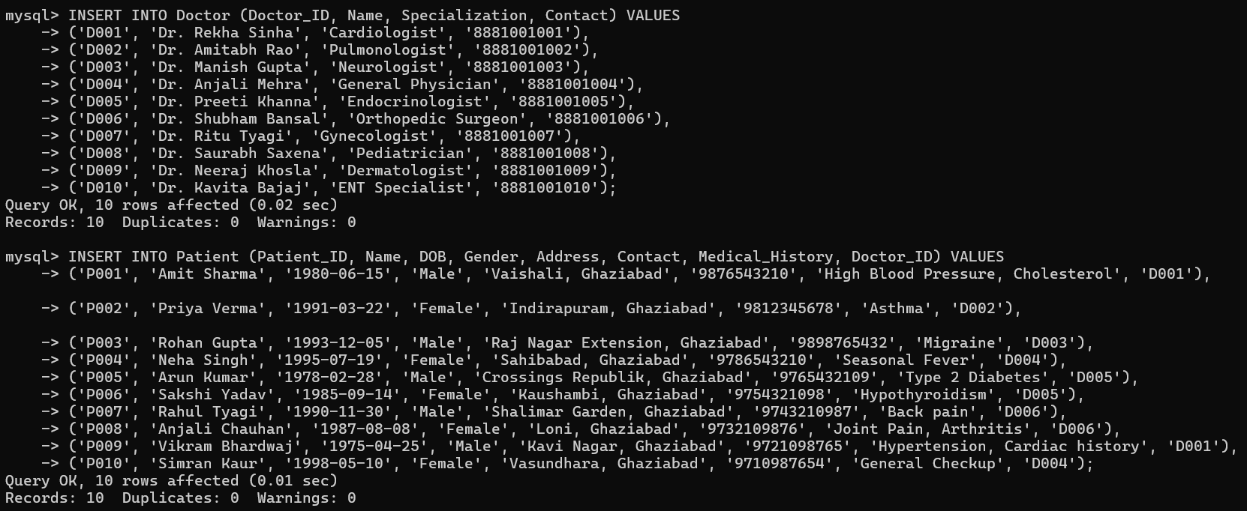

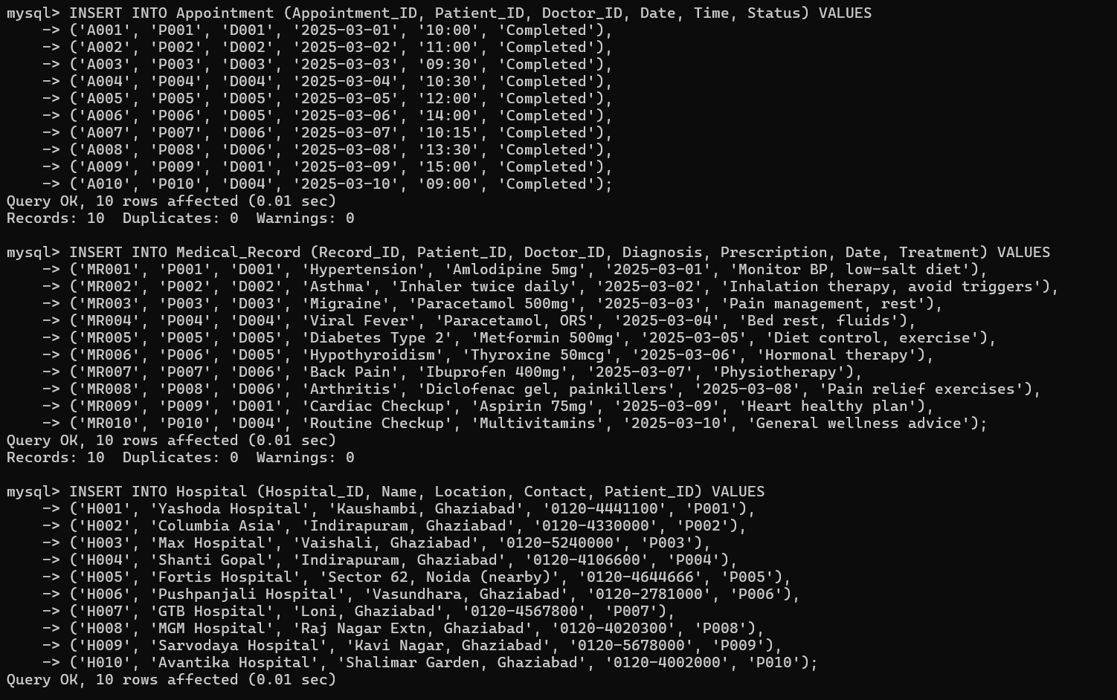

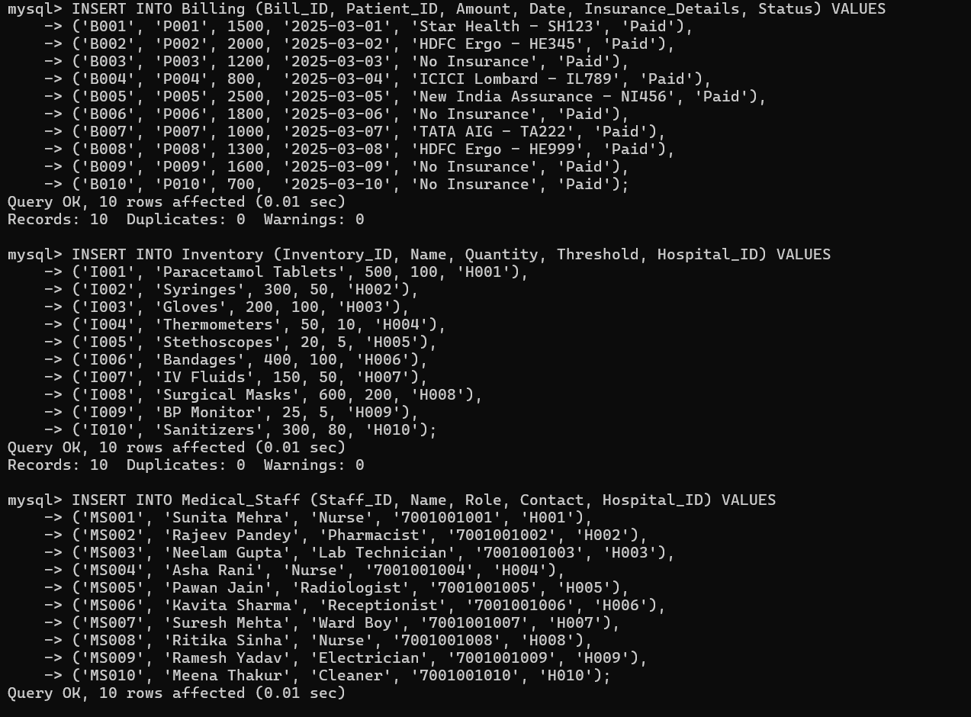

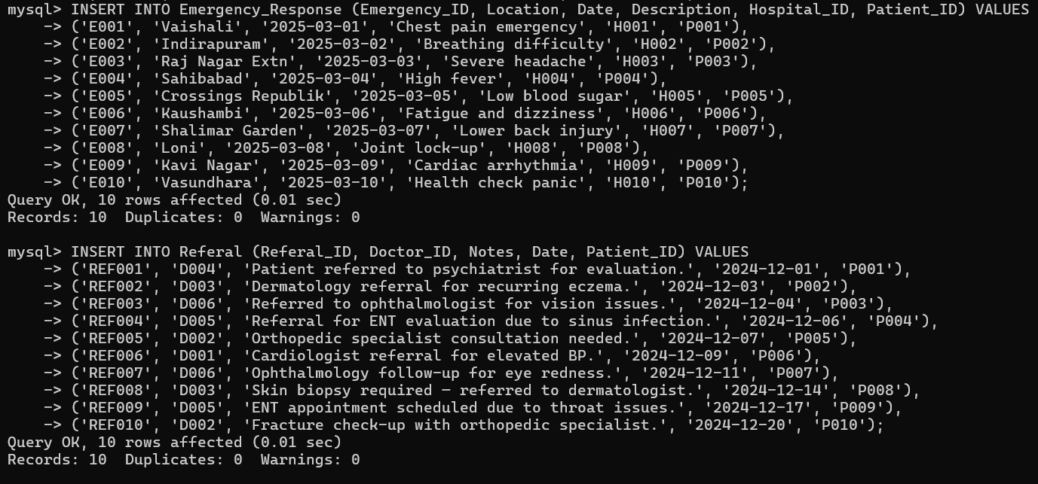

1. Table wise commands:

## Patient

SELECT * FROM Patient;

INSERT INTO Patient (Patient_ID, Name, DOB, Gender, Address, Contact, Medical_History, Doctor_ID)

VALUES ('P011', 'Ritika Sharma', '1992-04-20', 'Female', 'Raj Nagar, Ghaziabad', '9876500001', 'Asthma', 'D001');

UPDATE Patient SET Contact = '9876509999' WHERE Patient_ID = 'P011';

DELETE FROM Patient WHERE Patient_ID = 'P011';

ALTER TABLE Patient ADD Email VARCHAR(100);

## Doctor

SELECT * FROM Doctor;

INSERT INTO Doctor (Doctor_ID, Name, Specialization, Contact)

VALUES ('D007', 'Dr. Aarti Mehra', 'Pulmonologist', '9876543222');

UPDATE Doctor SET Contact = '9876501212' WHERE Doctor_ID = 'D007';

DELETE FROM Doctor WHERE Doctor_ID = 'D007';

ALTER TABLE Doctor ADD Email VARCHAR(100);

## Appointment

SELECT * FROM Appointment;

INSERT INTO Appointment (Appointment_ID, Patient_ID, Doctor_ID, Date, Time, Status)

VALUES ('A011', 'P001', 'D003', '2025-04-10', '14:00:00', 'Scheduled');

UPDATE Appointment SET Status = 'Completed' WHERE Appointment_ID = 'A011';

DELETE FROM Appointment WHERE Appointment_ID = 'A011';

ALTER TABLE Appointment ADD Mode VARCHAR(50); -- e.g., In-person or Virtual

## Medical record

SELECT * FROM Medical_Record;

INSERT INTO Medical_Record (Record_ID, Patient_ID, Doctor_ID, Diagnosis, Prescription, Date, Treatment)

VALUES ('MR011', 'P004', 'D005', 'Migraine', 'Paracetamol 650mg', '2025-03-18', 'Rest and hydration');

UPDATE Medical_Record SET Treatment = 'Medication and lifestyle changes' WHERE Record_ID = 'MR011';

DELETE FROM Medical_Record WHERE Record_ID = 'MR011';

ALTER TABLE Medical_Record ADD Follow_Up_Date DATE;

## Hospital

SELECT * FROM Hospital;

INSERT INTO Hospital (Hospital_ID, Name, Location, Contact, Patient_ID)

VALUES ('H011', 'Shanti Multi-Specialty', 'Vasundhara, Ghaziabad', '01206543210', 'P006');

UPDATE Hospital SET Contact = '01204567891' WHERE Hospital_ID = 'H011';

DELETE FROM Hospital WHERE Hospital_ID = 'H011';

ALTER TABLE Hospital ADD Email VARCHAR(100);

## Billing

SELECT * FROM Billing;

INSERT INTO Billing (Bill_ID, Patient_ID, Amount, Date, Insurance_Details, Status)

VALUES ('B011', 'P010', 5200.00, '2025-04-01', 'ICICI Lombard', 'Pending');

UPDATE Billing SET Status = 'Paid' WHERE Bill_ID = 'B011';

DELETE FROM Billing WHERE Bill_ID = 'B011';

ALTER TABLE Billing ADD Payment_Mode VARCHAR(50); -- e.g., Cash, UPI, Insurance

## Inventory

SELECT * FROM Inventory;

INSERT INTO Inventory (Inventory_ID, Name, Quantity, Threshold, Hospital_ID)

VALUES ('I011', 'Gloves (Latex-Free)', 1000, 200, 'H002');

UPDATE Inventory SET Quantity = Quantity - 100 WHERE Inventory_ID = 'I011';

DELETE FROM Inventory WHERE Inventory_ID = 'I011';

ALTER TABLE Inventory ADD Supplier_Name VARCHAR(100);

## Medical staff

SELECT * FROM Medical_Staff;

INSERT INTO Medical_Staff (Staff_ID, Name, Role, Contact, Hospital_ID)

VALUES ('S011', 'Ajay Rana', 'Technician', '9876543900', 'H001');

UPDATE Medical_Staff SET Role = 'Senior Technician' WHERE Staff_ID = 'S011';

DELETE FROM Medical_Staff WHERE Staff_ID = 'S011';

ALTER TABLE Medical_Staff ADD Shift VARCHAR(50); -- Morning/Evening/Night

## Referal

SELECT * FROM Referal;

INSERT INTO Referal (Referal_ID, Doctor_ID, Notes, Date, Patient_ID)

VALUES ('REF011', 'D006', 'Eye check-up for recurring headaches', '2025-04-07', 'P002');

UPDATE Referal SET Notes = 'Urgent eye check-up for blurry vision' WHERE Referal_ID = 'REF011';

DELETE FROM Referal WHERE Referal_ID = 'REF011';

ALTER TABLE Referal ADD Referral_Type VARCHAR(50); -- Internal/External

## Telemedicine

SELECT * FROM Telemedicine;

INSERT INTO Telemedicine (Tel_ID, Meeting_Link, Notes, Appointment_ID)

VALUES ('TEL011', 'https://meetdoc.in/session123', 'Discuss lab results', 'A004');

UPDATE Telemedicine SET Notes = 'Lab results explained, follow-up in 1 week' WHERE Tel_ID = 'TEL011';

DELETE FROM Telemedicine WHERE Tel_ID = 'TEL011';

ALTER TABLE Telemedicine ADD Duration_Mins INT;

## Emergency response

SELECT * FROM Emergency_Response;

INSERT INTO Emergency_Response (Emergency_ID, Location, Date, Description, Hospital_ID, Patient_ID)

VALUES ('EM011', 'Anand Vihar border', '2025-04-02', 'Accidental injury while commuting', 'H003', 'P003');

UPDATE Emergency_Response SET Description = 'Moderate head trauma due to road accident' WHERE Emergency_ID = 'EM011';

DELETE FROM Emergency_Response WHERE Emergency_ID = 'EM011';

ALTER TABLE Emergency_Response ADD Response_Time_Min INT;